**MERMAID Project**

**Seismic Induced Liquefaction in sand**

This task investigates the effects of seismic-induced liquefaction in the marine soil. This task is the first part of the research involving the effect of liquefaction on the stability of scour protection. The products obtained will be a study report (or paper) on sinking of scour protection around foundations under seismic-induced loading.

1. **Centrifuge Test DE01**

This test was performed by Daniella Escribano on the 9th of July 2014 and consisted of a centrifuge model test at 50-g level and a dynamic shaker. The motions considered for this test have been previously calibrated. The objective of this test was to evaluate liquefaction of sand.

* 1. **Material**

The sand used corresponds to HST95 Congleton sand, which is a specific fraction of the sand extracted at Bent farm, Congleton, Cheshire. It is classified as a fine grained sand and its mineralogical composition consists at 94% of quartz. Lauder (2010). The roundness index (R) is 0.53 (Lauder, 2010) classifying this material as round particle shape. The physical properties of Congleton sand are given in Table 1.

Table 1. Physical properties of HST95 Congleton sand

|  |  |
| --- | --- |
| Property | Bertalot (2013) |
| *D10* (mm) | 0.07 |
| *D30* (mm) | 0.10 |
| *D60* (mm) | 0.146 |
| *Cu* | 1.96 |
| *Gs* | 2.63 |
| *γd,min*(kN/m3) | 14.34 |
| *γd,max*(kN/m3) | 17.60 |
| *emax* | 0.795 |
| *emin* | 0.463 |

* 1. **Model preparation**

The sand was placed by air pluviation method. First of all the sand was passed through a mesh from a storage hopper. The density obtained was previously calibrated for different heights, and was continually monitored through the pluviation process in order to maintain a constant height. The target density varied between 35% and 40% relative density.

For model saturation the model container has 5 inlets in the base in order to distribute the pore fluid homogeneously at the bottom of the soil model. The inlets are then connected to 10 mm pipes to the fluid container. A certain fluid pressure gradient was selected between the bottom and top of the model, as well as reducing the velocity rate of the fluid by connecting a needle valve. The saturation process was slow enough to avoid piping of the soil model.

In order to increase the viscosity of the fluid for a gravitational acceleration of 50-g, a mixture of de-aired water and Hydroxypropyl methylcellulose (HPMC) was used. The final viscosity obtained was 45%, and was calculated based on the correlation between viscosity *ν,* measured at 20°C, and the concentration in weight *C* of the HPMC (Stewart et al., 1998). The lower value of final viscosity obtained compared to the target viscosity of 50% could be because the fluid was not mixed in its container before obtaining a sample for measurements.

* 1. **Calibration of motions used for centrifuge model tests**

The calibration of motions is necessary because the QS67-2 earthquake simulator has to match as close as possible the reference input motion. In order to do this test, a dummy model is performed with similar characteristics of the actual model, in terms of weight and weight distribution. The layout of the model used for calibration is given in Figure 1 and the calibrated motions had an amplitude of 1.5-g, 2.5-g, 4-g, and 5-g (model scale). These motions are shown in Appendix A at the prototype scale amplitude. The calibration of the highest amplitude of 5-g (prototype amplitude acceleration of 0.1-g) was stopped before completing the total number of cycles (80 cycles) due to limitations of the equipment at that moment. However, in the present the shaking table has been refurbished in order to apply higher amplitudes.

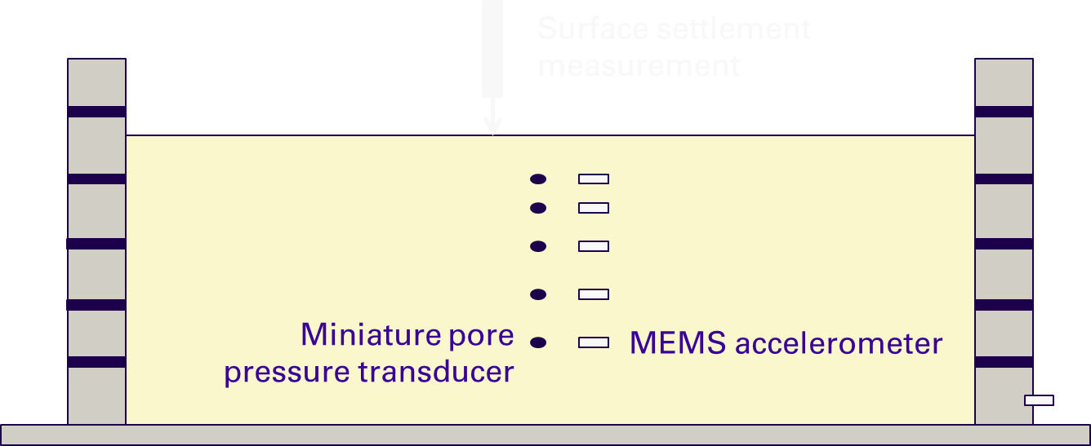

Figure 1. Dummy model for calibration of motions

* 1. **Sand model for liquefaction analysis**

This test was performed at 50-g, with an input sinusoidal motion previously calibrated, with an amplitude of 4-g, and a frequency of 10 kHz. The model layout and instrumentation is shown in Figure 2. The instrumentation is illustrated with symbols as: PPT: pore pressure transducers, ACC: accelerometers, and LVDT: linear variable differential transformers. Most of the instrumentation was installed at the centreline of the box where boundary effects of the box should be minimum. The sand was poured from a funnel to a void ratio of approximately 0.66 to create the scaling factors listed in Table 2. The real model is shown in Figure 3, with some small light plastic rafts used to prevent penetration of the LVDTs.

The data of each transducer is plotted in Appendix B, where accelerometers (ACC) have units of *g*, LVDTs have units in mm, and pore pressure transducers (PP) have units in kPa. The location of each transducer is detailed in Figure 2, and the input channel to the datascan unit is specified in Table 3. The datascan unit corresponds to two boxes, each one with 27 channels.

The input motion was recorded with a PE (piezo-electric) accelerometer glued at the base of the shaking table (Figure 4). It is observed that the amplitude is higher than the one introduced in the control software. The average amplitude obtained through the PE accelerometer is 5-g.



Figure 2. Model layout and instrumentation: PPT: pore pressure transducer; ACC: accelerometer, LVDT: Linear variable differential transformer. Dimensions in mm.

Table 2. Useful centrifuge scaling factors

|  |  |  |  |
| --- | --- | --- | --- |
| Parameter | Dimensions | Prototype | Model, N-g |
| *Stress, pressure* | ML-1T-2 | 1 | 1 |
| *Strain* | - | 1 | 1 |
| *Length, displacement* | L | 1 | 1/N |
| *Velocity* | LT-1 | 1 | 1 |
| *Acceleration, gravity* | LT-2 | 1 | N |
| *Mass* | M | 1 | 1/N3 |
| *Volume* | L3 | 1 | 1/N3 |
| *Force* | MLT-2 | 1 | 1/N2 |
| *Frequency* | T-1 | 1 | N |

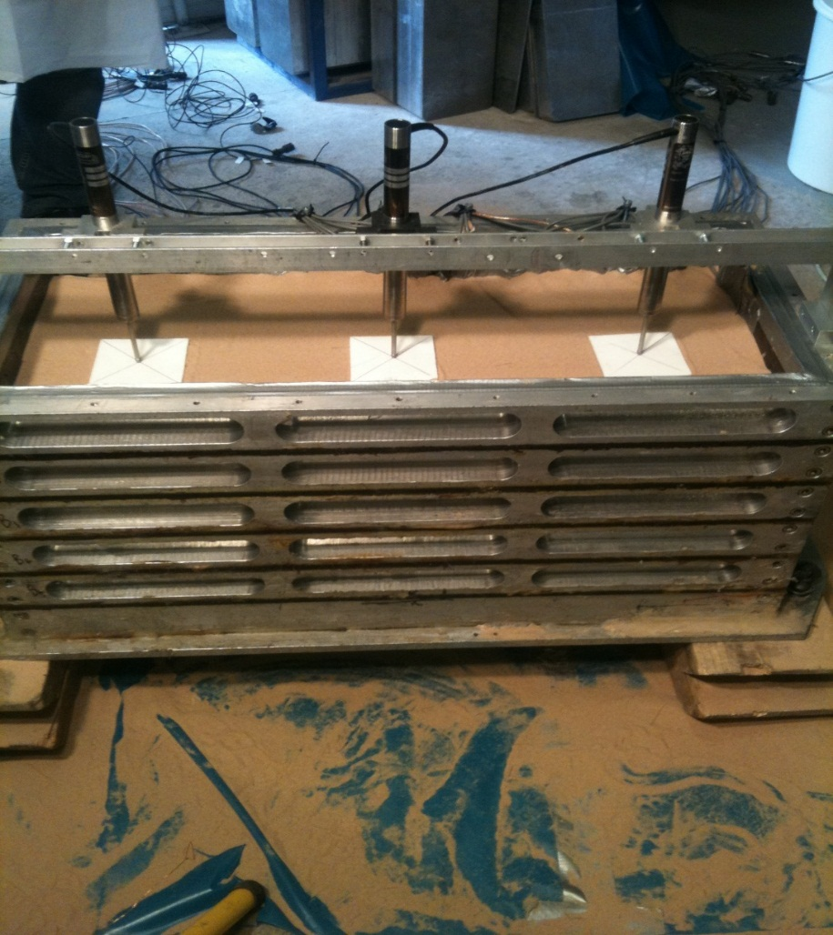

Figure 3. Light plastic rafts for LVDTs to rest.



(a)



(b)

Figure 4. Recorded acceleration (g) at the base of shaking table: (a) Acceleration vs time, (b) Fourier Transform vs frequency. Data at model scale.

Table 3. Instrument channels

|  |  |  |  |
| --- | --- | --- | --- |
| Channel | Instrument | Calibration factor | Comments |
| Box 1 – chan2 | ACC2 | -35.2221 |  |
| Box 1 – chan3 | ACC5 | - | Didn’t work |
| Box 1 – chan4 | ACC10 | -34.8298 |  |
| Box 1 – chan5 | ACC9 | -36.1083 |  |
| Box 1 – chan6 | ACC7 | -38.2323 |  |
| Box 1 – chan7 | ACC3 | - | Didn’t work |
| Box 1 – chan8 | ACC11 | - | Didn’t work |
| Box 1 – chan9 | PPT9 | 45.8629 |  |
| Box 1 – chan10 | PPT2 | 44.7971 |  |
| Box 1 – chan11 | PPT3 | 45.3592 | Didn’t work |
| Box 1 – chan18 | LVDT2 | 10.8920 |  |
| Box 1 – chan20 | LVDT3 | 11.3650 |  |
| Box 1 – chan21 | LVDT1 | 11.3820 |  |
| Box 1 – chan25 | PPT4 | 45.8220 |  |
| Box 1 – chan26 | PPT5 | 45.7171 |  |
| Box 1 – chan27 | PPT6 | 45.7059 |  |
| Box 2 – chan1 | ACC6 | -36.5223 |  |
| Box 2 – chan2 | ACC13 | -35.5842 |  |
| Box 2 – chan3 | ACC1 | -36.7529 |  |
| Box 2 – chan4 | ACC15 | -35.8953 |  |
| Box 2 – chan5 | ACC4 | -36.8260 |  |
| Box 2 – chan6 | ACC8 | -35.7344 |  |
| Box 2 – chan7 | ACC12 | -35.8984 |  |
| Box 2 – chan8 | ACC14 | -37.1211 |  |
| Box 2 – chan9 | PPT7 | 45.3581 |  |
| Box 2 – chan10 | PPT8 | 39.0101 |  |
| Box 2 – chan11 | PPT10 | 37.6076 |  |
| Box 2 – chan25 | PPT11 | 37.7758 |  |
| Box 2 – chan26 | PPT1 | 39.1007 |  |
| Box 1 – chan1 | ACCBase | 20 | Located at the base of the shaking table |

**APPENDIX A: Calibrated motions in terms of acceleration against time.**

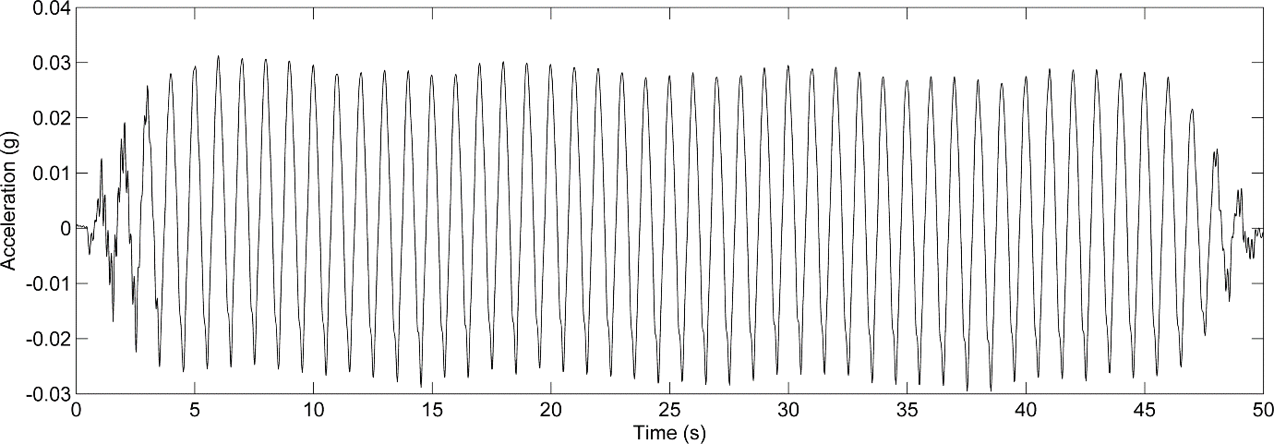

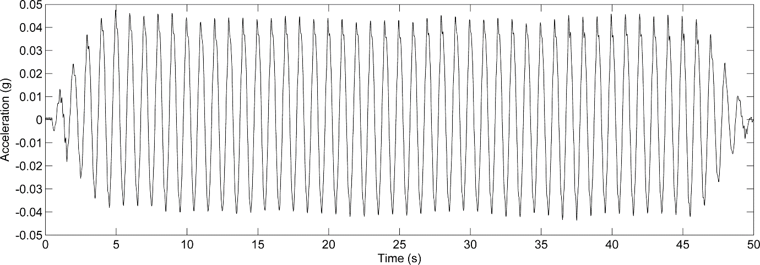

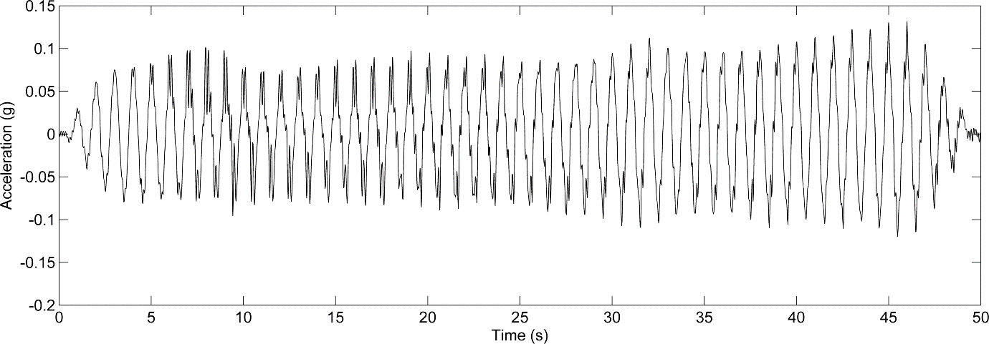

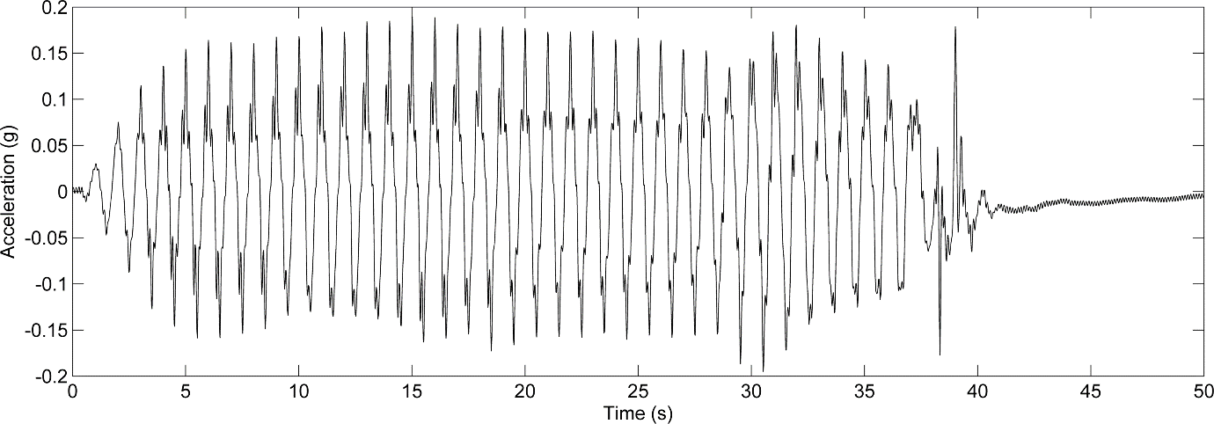

**APPENDIX B-1: Recorded data of accelerometers, from 1 to 8.**



**APPENDIX B-2: Recorded data of accelerometers, from 9 to 15.**



**APPENDIX B-3: Recorded data of pore water pressure transducers, from 1 to 5.**



**APPENDIX B-4: Recorded data of pore water pressure transducers, from 6 to 11.**



**APPENDIX B-4: Recorded data of displacement transducers LVDTs, from 1 to 3.**

